Drozd Sophie 215

The easiest way to check this homeworks would be by looking at the screenshots of diagrams. After each photo there is the code, which can be compiled here: <https://app.quickdatabasediagrams.com/#/>

Each of the tasks has both a screenshot and the code.

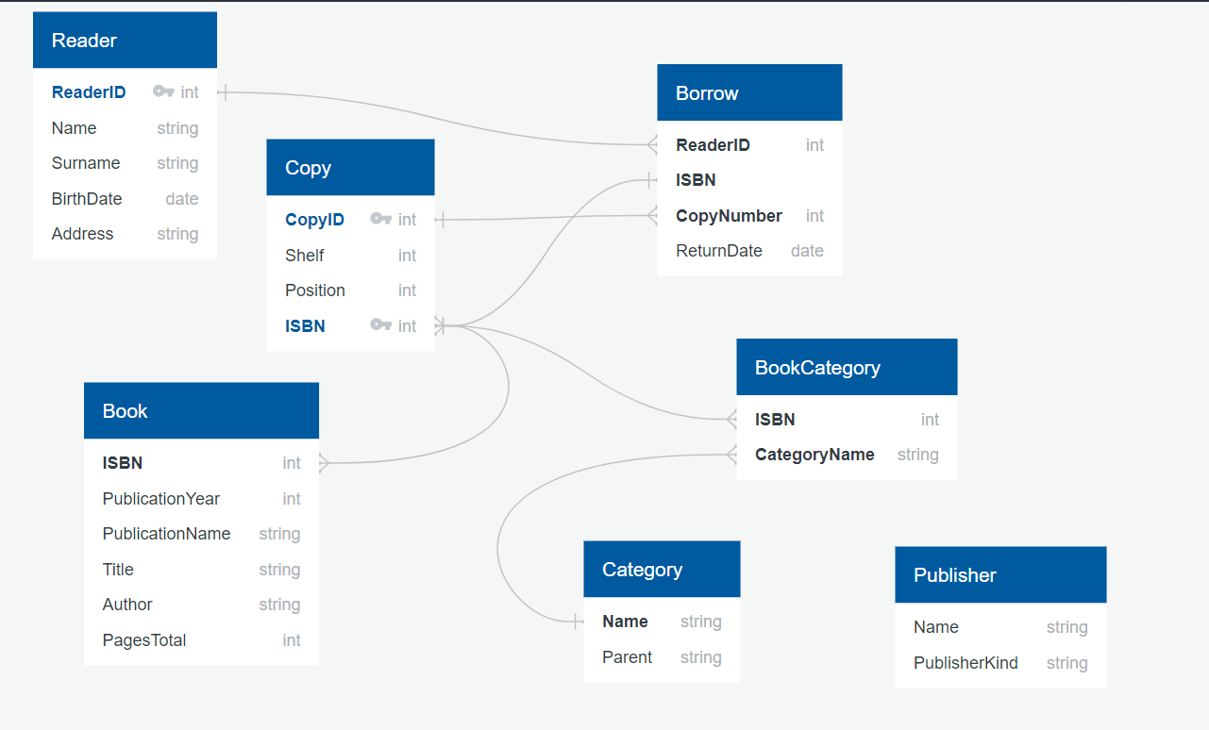

Reader as r

-

ReaderID PK int

Name string

Surname string

BirthDate date

Address string

Book as b

-

ISBN int FK >- Copy.ISBN

PublicationYear int

PublicationName string

Title string

Author string

PagesTotal int

Copy as c

-

CopyID PK int

Shelf int

Position int

ISBN PK int FK >- b.ISBN

Borrow as b

-

ReaderID int FK >- r.ReaderID

ISBN

CopyNumber int FK >- c.CopyID

ReturnDate date

Publisher as p

-

Name string

PublisherKind string

Category as cat

-

Name string

Parent string

BookCategory

-

ISBN int FK >- Copy.ISBN

CategoryName string FK >- cat.Name

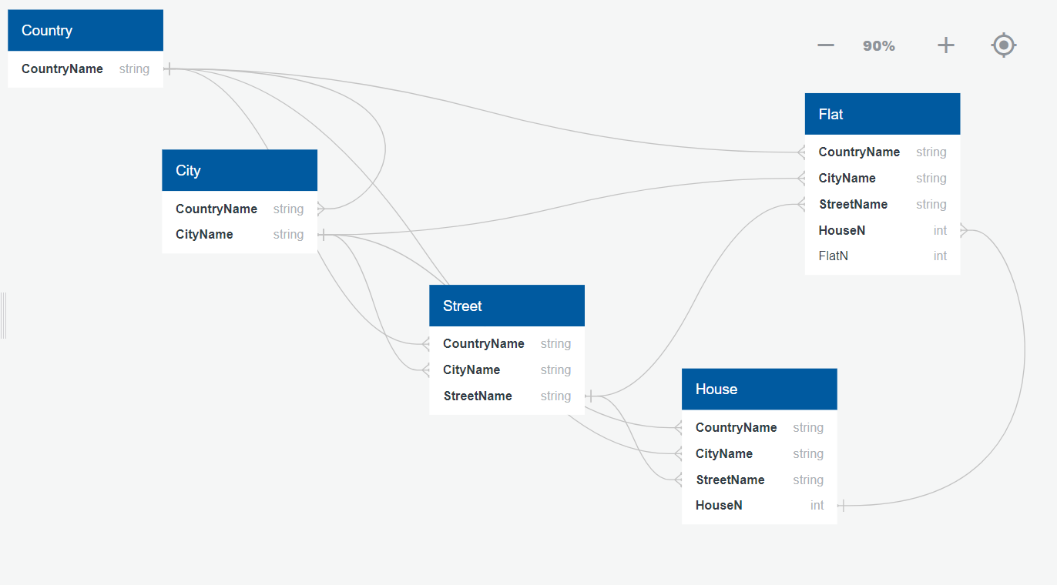

Country as c

-

CountryName string

City as ct

-

CountryName string FK >- c.CountryName

CityName string

Street as s

-

CountryName string FK >- c.CountryName

CityName string FK >- ct.CityName

StreetName string

House as h

-

CountryName string FK >- c.CountryName

CityName string FK >- ct.CityName

StreetName string FK >- s.StreetName

HouseN int

Flat

-

CountryName string FK >- c.CountryName

CityName string FK >- ct.CityName

StreetName string FK >- s.StreetName

HouseN int FK >- h.HouseN

FlatN int

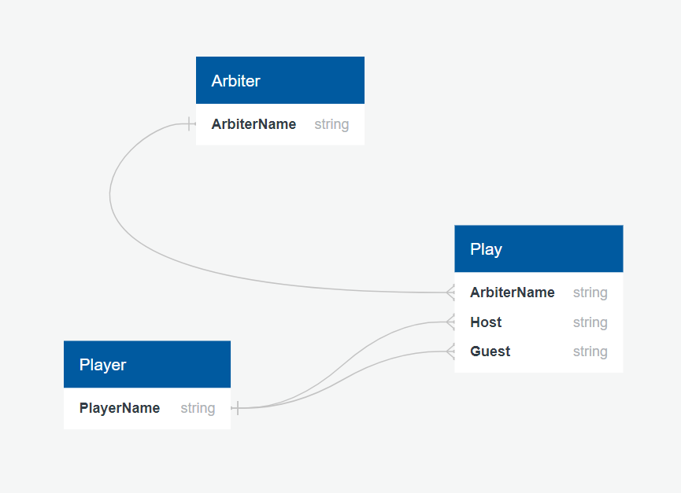

Player as p

-

PlayerName string

Arbiter as a

-

ArbiterName string

Play

-

ArbiterName string FK >- a.ArbiterName

Host string FK >- p.PlayerName

Guest string FK >- p.PlayerName

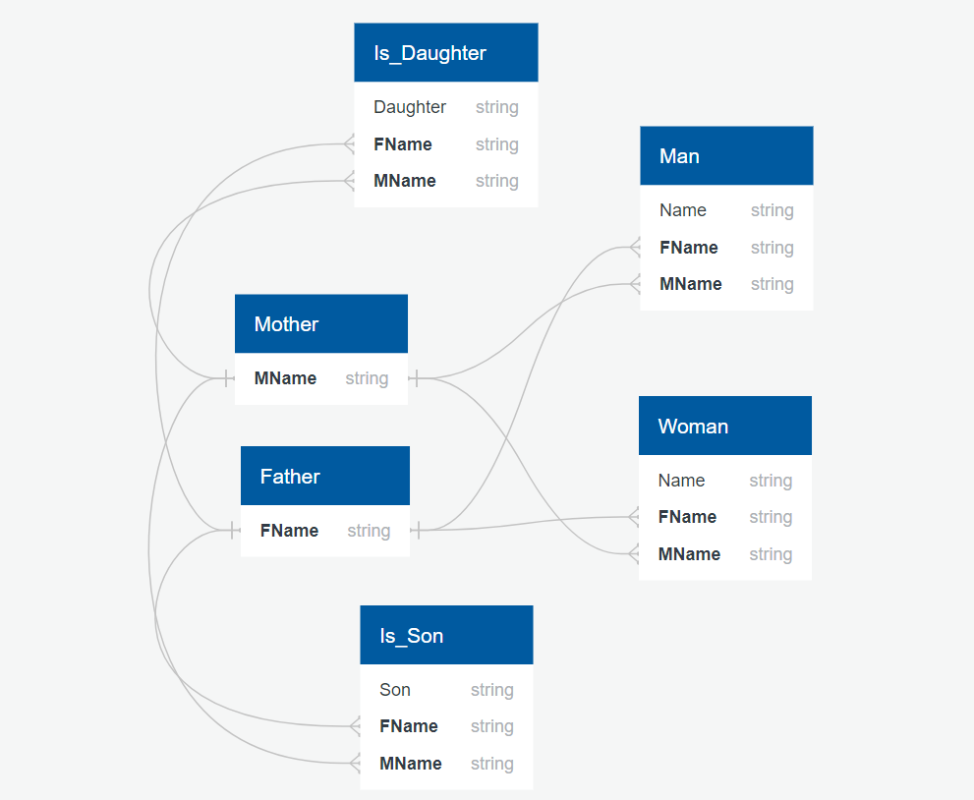

Father as f

-

FName string

Mother as m

-

MName string

Is_Son as is

-

Son string

FName string FK >- f.FName

MName string FK >- m.MName

Is_Daughter as id

-

Daughter string

FName string FK >- f.FName

MName string FK >- m.MName

Man

-

Name string

FName string FK >- f.FName

MName string FK >- m.MName

Woman

-

Name string

FName string FK >- f.FName

MName string FK >- m.MName

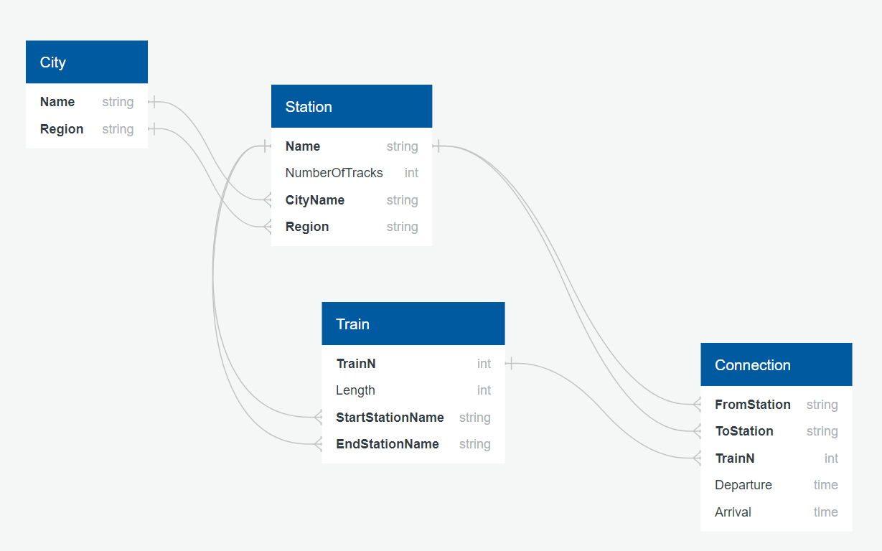

City as c

-

Name string

Region string

Station as s

-

Name string

NumberOfTracks int

CityName string FK >- c.Name

Region string FK >- c.Region

Train as t

-

TrainN int

Length int

StartStationName string FK >- s.Name

EndStationName string FK >- s.Name

Connection

-

FromStation string FK >- s.Name

ToStation string FK >- s.Name

TrainN int FK >- t.TrainN

Departure time

Arrival time

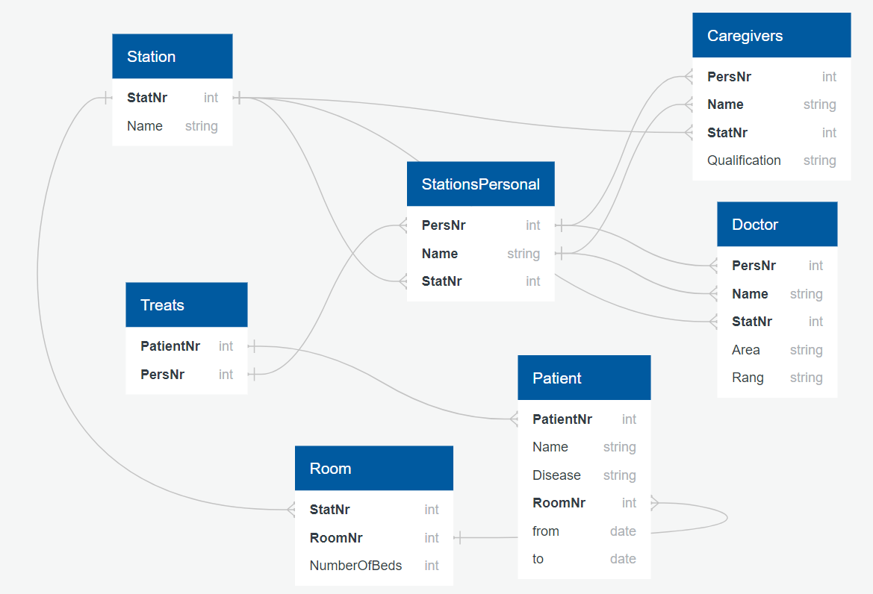

Station as s

-

StatNr int

Name string

Room as r

-

StatNr int FK >- s.StatNr

RoomNr int

NumberOfBeds int

Patient as p

-

PatientNr int FK >- Treats.PatientNr

Name string

Disease string

RoomNr int FK >- r.RoomNr

from date

to date

Treats

-

PatientNr int

PersNr int

StationsPersonal as sp

-

PersNr int FK >- Treats.PersNr

Name string

StatNr int FK >- s.StatNr

Doctor as d

-

PersNr int FK >- sp.PersNr

Name string FK >- sp.Name

StatNr int FK >- s.StatNr

Area string

Rang string

Caregivers as c

-

PersNr int FK >- sp.PersNr

Name string FK >- sp.Name

StatNr int FK >- s.StatNr

Qualification string